 | 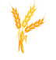 |  | 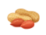 |  |  |  | 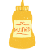 |  | 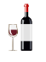 |  | 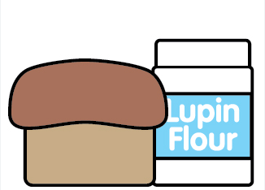 |  |  | 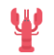
Pizza Parties | Cereals containing gluten | Eggs | Peanuts | Milk | Nuts | Celery | Mustard | Sesame | Sulphites | Molluscs | Lupin | Fish | Soya  Bean | Crustaceans
Ingredients:
Flour
Olive Oil
Yeast
Passata
Cheese
Sweetcorn
Peppers
Mushrooms
Drinks:
Orange Squash
Blackcurrant Squash
Milk
Allergen Alternatives:
Dairy free cheese
Gluten free bases

THE FOODS WE COOK AND THEIR ALLERGEN CONTENT

Important: There are 14 major food allergens to be aware of.

The chart shows the ingredients used, for Pizza Parties at Barleylands and if they contain any of the 14 major allergens.

